**Natural Language Processing (NLP)**

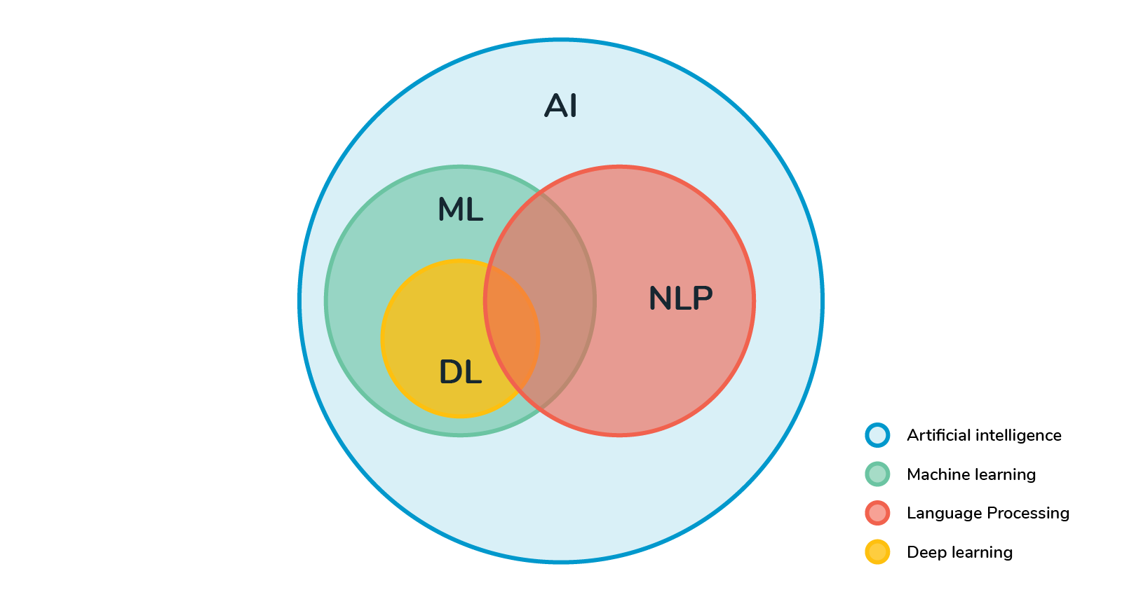

Natural language processing is a subset of Artificial intelligence that helps computers to understand, interpret, and utilize the human languages. NLP allows computers to communicate with peoples using human languages. NLP also provides computers with the ability to read text, hear speech, and try to interpret it. NLP draws several disciplines, including Computational linguistics and computer science, as this attempts to fill the gap in between human and computer communication.

NLP breaks down language into shorter, more basic pieces, called tokens (period, words, etc), and attempts to understand the relationships of tokens. This approach often uses higher-level NLP features, such as:

* **Sentiment analysis:** It identifies the general mood, or subjective opinions, which is stored in large number of texts, it is more useful for opinion mining.
* **Contextual Extraction:** Extract structured data from text-based sources.
* **Text-to-Speech and Speech-to-text:** It transforms the voice into text and vice a versa.
* **Document Summarization:** Automatically creates a synopsis, condensing large amounts of text.
* **Machine Translation:** Translates the text or speech of one language into another language.

# **Why learn NLP?**

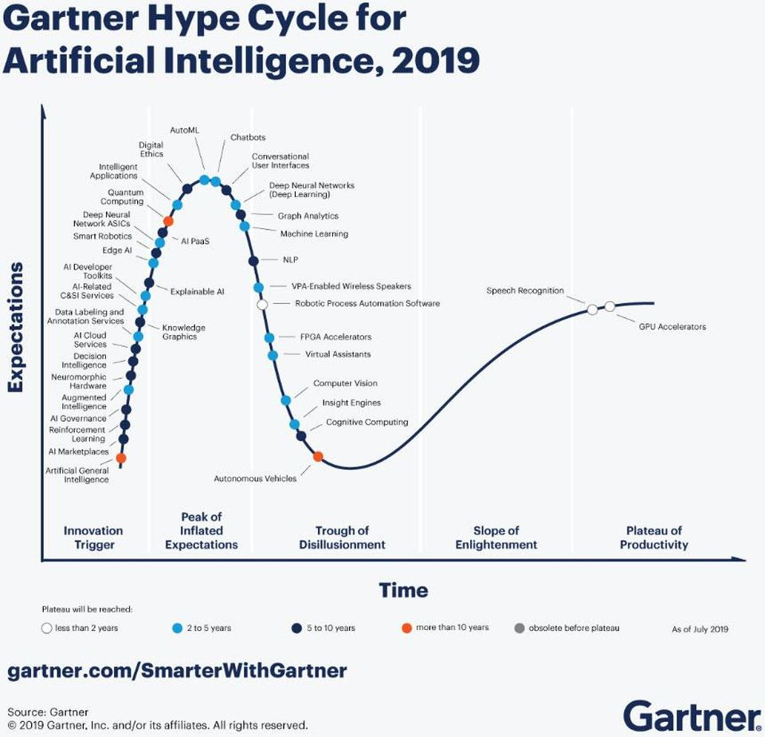

You need to see the Gartner's new hype cycle, I start my discussion with this, you can clearly see NLP are on the top of the cycle. Currently, Natural Language Processing (NLP) is one of the rarest skill sets that is required for the industry. After appearance of big data, the main challenges come like we need more people who are good with not just for structured but also with semi or unstructured data. We are generating **petabytes** of Weblogs, tweets, Facebook feeds, chats, e-mails, and reviews in a day. Companies are trying to collect all these different kind of data for better customer targeting and meaningful insights. To process all these unstructured data source, we need those people who have the thorough experience in NLP.

We are in the age of information; we can't even imagine our life without *Google*. We use basic stuffs with Alexa and Siri and we are habitual with these two. We use spam filters for filtering spam emails. We need spell checker on our Word documents. There were many more examples of real world NLP applications around us.

Let me give you some examples like they are built with the use of NLP but we are not aware of it:

* Spell Correction (MS Word/any other editor)
* Search engines (Google, Bing, Yahoo)
* Speech engines (like Siri, Google assistant)
* Spam classifiers (All e-mails services)
* News feeds (Google, Yahoo!, and so on)
* Machine Translation (Google translation)
* IBM Watson

Building these above applications, we need a required, very specific skill set with a great understanding of language and tools to process the language efficiently. So, it's not just hype that makes NLP one of the most niche areas, but it's the kind of application that can be created using NLP (Natural Language Processing) that makes it one of the most unique skills to have. To achieve one of the above applications and other basic NLP pre-processing, there are many open source tools available. Some of them which are made by organizations to build their own NLP applications, while some of the organizations have open-sourced. Here is the small list of NLP tools are available:

* Spacy
* Open NLP
* Text blob
* Standford toolkit
* Gensim
* **NLTK (Natural Language Tool kit)**

Most of the tools are written in Java and have similar functionalities. And Some of them are robust and have a different variety of NLP tools are available. However, when it comes to ease to use and explanation of the concepts, NLTK scores really high. NLTK tool is also a best learning kit because the learning curve of Python (NLTK is written on this) is very fast. NLTK incorporated most of the NLP tasks, it's too elegant and easy to work with. For all these kinds of reasons, NLTK became one of the popular libraries in the NLP community.

# **Usage of NLP?**

In a real-world many more tools we use every day, let's get a brief of some of the tools:

### **1. Search Autocomplete**

It is another type of NLP that many people use on a daily basis and have almost get what you expect when you are searching. This is thanks in large part to pioneers like Google, Google has been using these features in their search engines for years. This feature is also much helpful in companies’ website.

Search autocomplete will provide help to locate the correct information and answer their questions fatalities helps to cutdown the likelihood that they'll became disinterested and navigate away from the site.

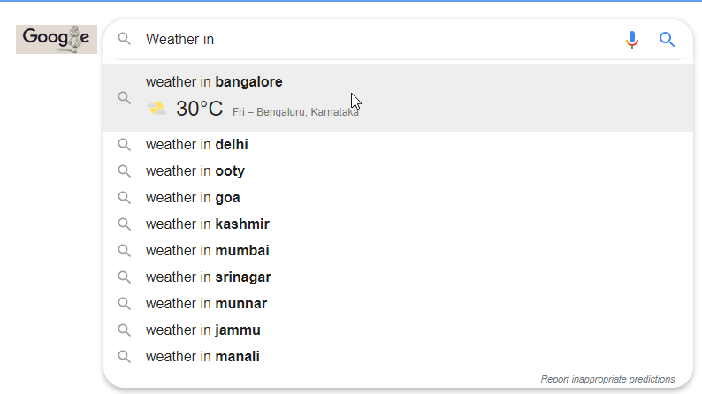

### **2.Search Autocorrect**

When we are typing something, we won't realize and make some mistakes while typing. If a search engine on a website won't catch those mistakes and instead show no results, then potential buyers might assume like you don't have the information or answer's they are looking for and may instead go to the competitor.

We see these when we type something wrong and Google's search engine will autocorrect your result and give a correct information about the topic.

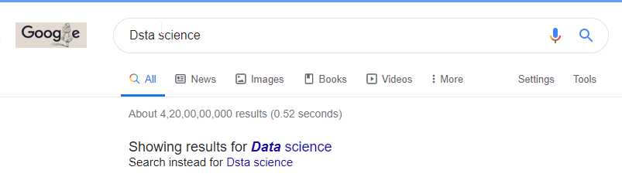

### **3.Machine Translation**

Suppose you're in China and you don't know Chinese and you have to ask some address to local people but they are conversing to you in Chinese then at that time Machine translation is saviour for you. One of the famous machine translation tools made by google, it will give you probably correct results always.

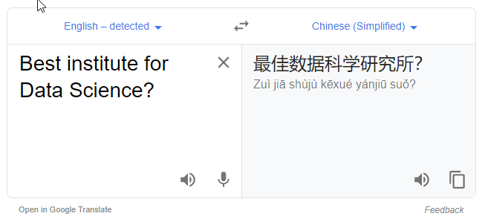

### **4.Messenger Bots**

Facebook messenger is one of the best and latest ways to connect with customers for business purposes through a social media. NLP makes it possible to extend the functionality of these bots so that they are not just advertising a product or services, but can interact with their customers and provide them a unique experience.

In 2015, Uber launched its Facebook messenger bot. This bot makes a quick and easy for user to order their cars from the Facebook Messenger app. And it would be too useful for a customer to just type their address and the messenger bot will fetch your address and put it up in their pickup address.

